Mind Track - Mini Project - 1

Created a EKS cluster named my-cluster

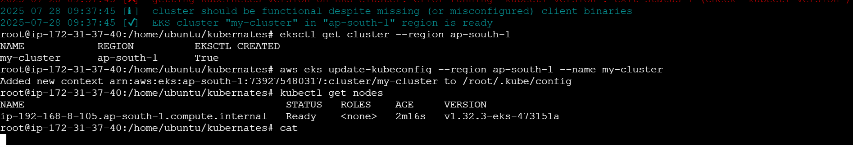

EKS cluster

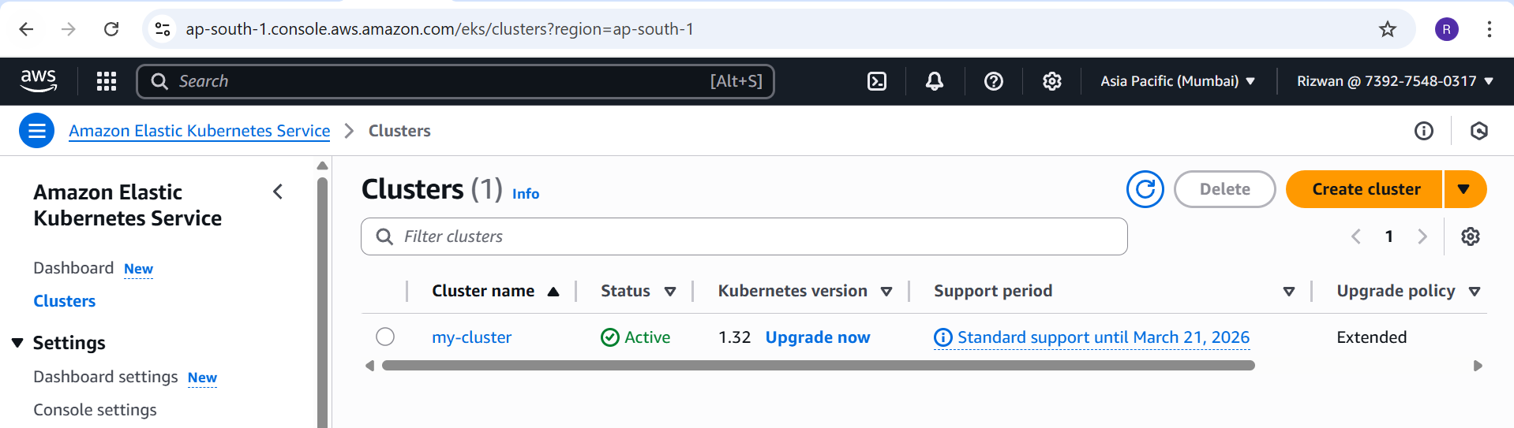

Worker Node

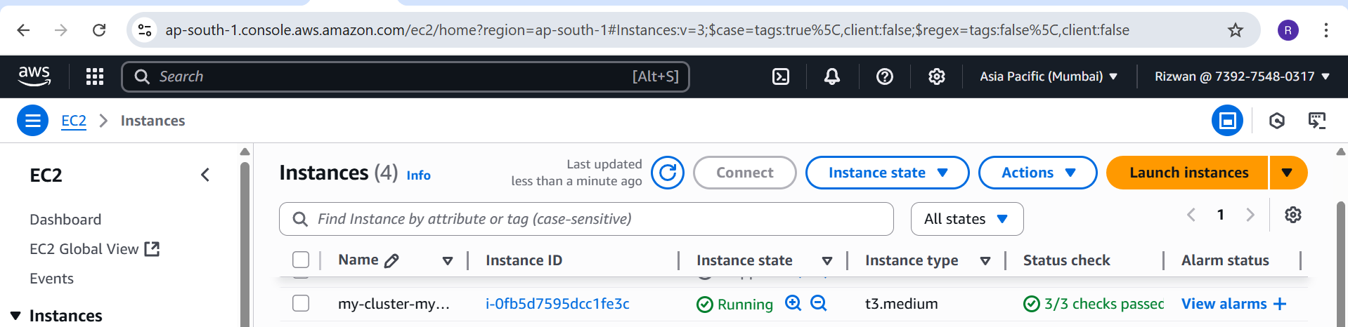

Brain Task app code pushed in to GIT

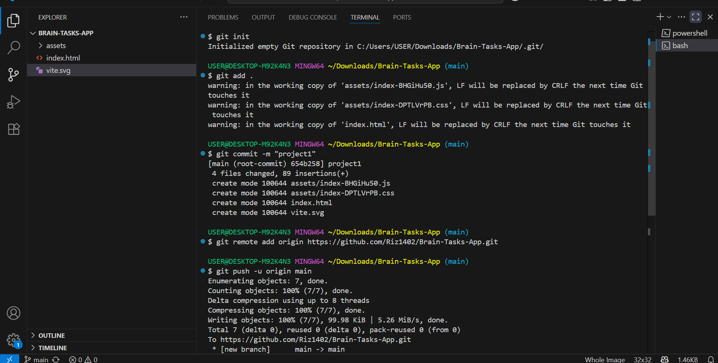

Docker file , deployment.yaml ,buildspec.yaml files created and push to GIT

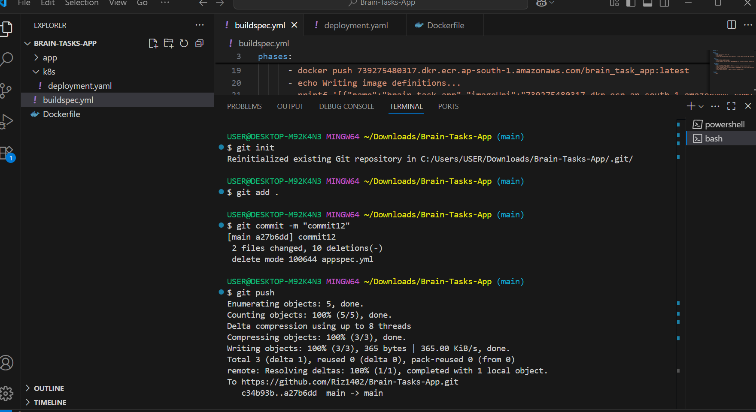

GIT Repository - <https://github.com/Riz1402/Brain-Tasks-App.git>

AWS Pipeline created and executed.

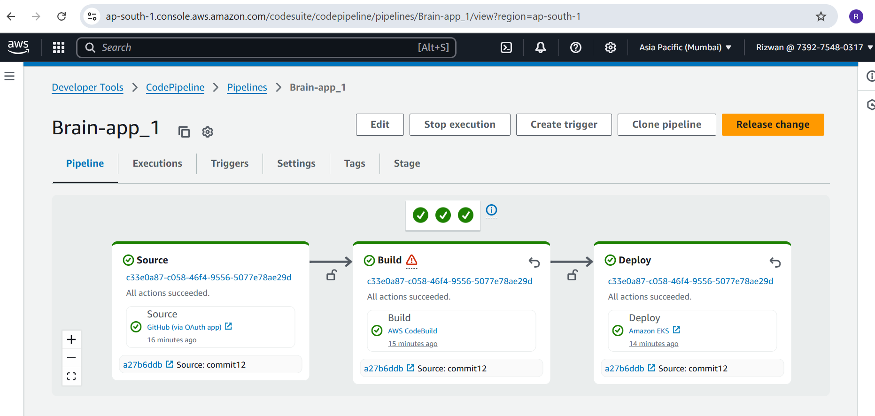

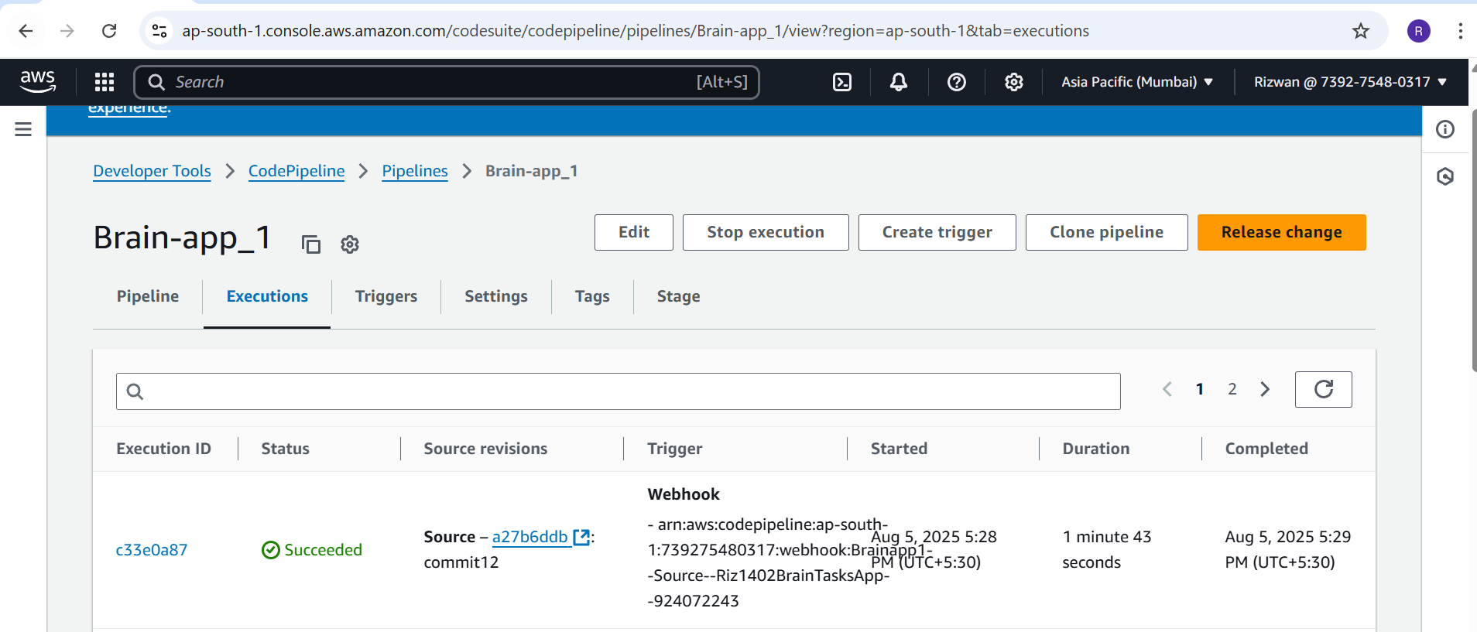

Created ECR Repository.

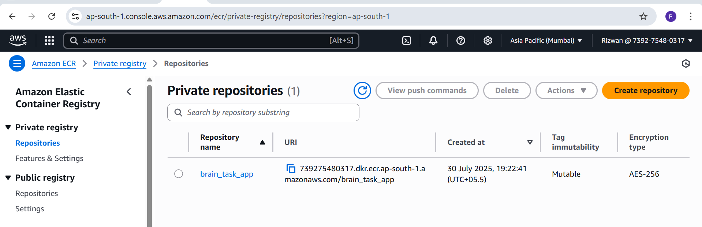

Docker image was created and pushed by pipeline

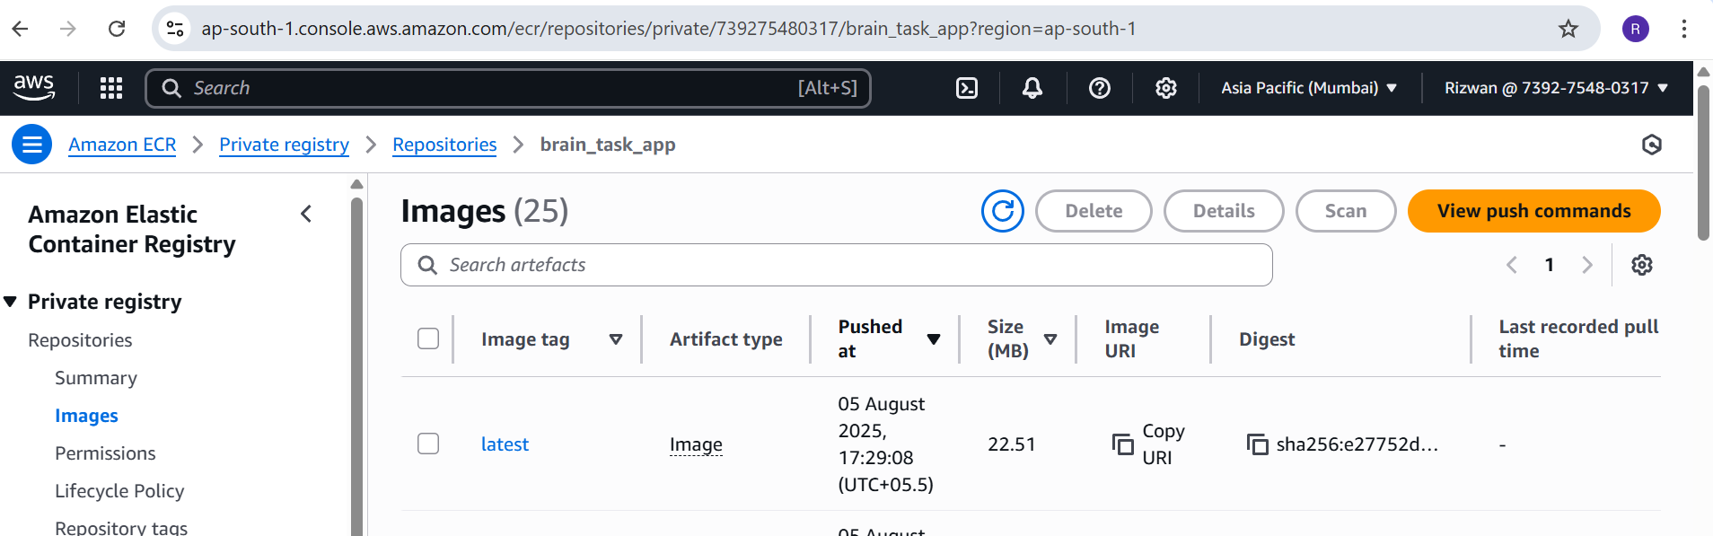

Kubernetes pods , Deployment and Service

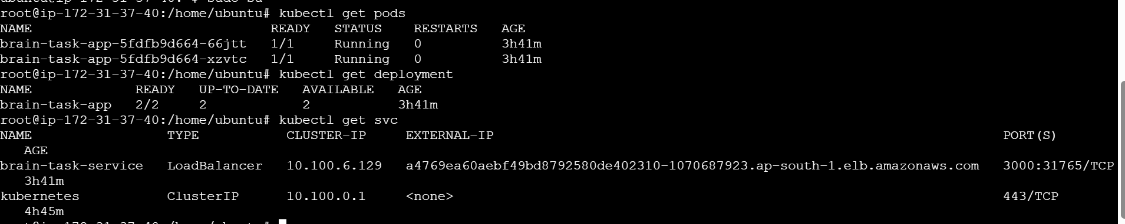

APP Screen

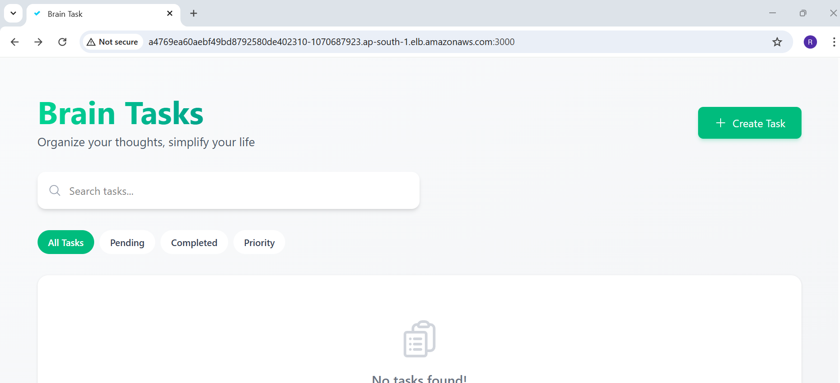

Monitoring using CloudWatch

